DR, SRINIBASH DASH

ASSOCIATE PROFESSOR & HEAD

SCHOLL OF MANAGEMENT

GMU, SBP

**Motivation Theories: Content and Process**

4 min read

**There are two important types of motivation theory: content and process. Content models of motivation focus on what people need in their lives (i.e. what motivates them). Process theories look at the psychological and behavioral processes that affect and individual’s motivation.**

**Summary by The World of Work Project**

**Motivation Theories: Introduction**

Though people have been interested in the idea of motivation for a long time, the first real models of human motivation that people still regularly refer to originated in the 1940s and 1950s.

Since then, many different models and frameworks of motivation have been published. These models fall into two main types of models: content models and process models. More recently, newer types of models have been introduced. That said, content and process theories often form the platform on which these newer models are built.

Having a good understanding of different theories of motivation is a great help for leaders and managers at all levels.

**Content Models of Motivation**

Content models of motivation focus on the “whats” of motivation. More specifically they focus on the different things that people may feel they need in their lives. The theory is that people’s motivations will be based on acquiring the things that they think they need. Thus, by understanding their wants and needs, you can understand why and how people are motivated.

The content model school of motivation theory is the older of the two schools. Content models are currently very popular in management and leadership training and the world of work.

Some famous content models include:

* [Maslow’s Hierarchy of Needs](https://worldofwork.io/2019/02/maslows-hierarchy-of-needs/),
* [Herzberg’s Two Factors Theory](https://worldofwork.io/2019/02/herzbergs-two-factor-theory-of-motivation/),
* [McClelland’s Theory of Needs](https://worldofwork.io/2019/02/mcclellands-motivation-theory/), and
* [Alderfer’s ERG Theory](https://worldofwork.io/2019/02/alderfers-erg-theory-of-motivation/).

**What is Maslow’s Hierarchy of Needs?**

Maslow’s hierarchy of needs is a theory of psychology explaining human motivation based on the pursuit of different levels of needs. The theory states that humans are motivated to fulfill their needs in a hierarchical order. This order begins with the most basic needs before moving on to more advanced needs. The ultimate goal, according to this theory, is to reach the fifth level of the hierarchy: self-actualization.

Maslow’s hierarchy of needs is often referenced in business classes with regard to organizational behavior and human resources. Climb up Maslow’s hierarchy and reach self-actualization with CFI’s Financial Modeling & Valuation Analyst (FMVA)® Certification Program!

**Maslow's Hierarchy of Needs**

History

Maslow’s hierarchy of needs was first introduced in Abraham Maslow’s 1943 paper, “A Theory of Human Motivation“. Maslow later refined this theory in 1954 with his book, “Motivation and Personality“. Since then, this theory has remained a popular subject in sociology, management training, and psychology classes.

**Levels of Hierarchy**

There are five main levels to Maslow’s hierarchy of needs. These levels begin from the most basic needs to the most advanced needs. Maslow originally believed that a person needed to completely satisfy one level to begin pursuing further levels.

A more modern perspective is that these levels overlap. As a person reaches higher levels, their motivation is directed more towards these levels. However, though their main focus is on higher levels, they will still continue to pursue lower levels of the hierarchy but with less intensity.

Learn how psychology relates to financial analysis. Corporate Finance Institute offers a behavioral finance course for those interested in how psychology affects investing decisions!

**#1: Physiological Needs**

Physiological needs are the lowest level of Maslow’s hierarchy of needs. They are the most essential things a person needs to survive. They include the need for shelter, water, food, warmth, rest, and health. A person’s motivation at this level derives from their instinct to survive.

**#2: Safety Needs**

The second level of Maslow’s hierarchy of needs consists of safety needs. Safety, or security needs, relate to a person’s need to feel safe and secure in their life and surroundings. Motivation comes from the need for law, order, and protection from unpredictable and dangerous conditions.

There are many examples of safety needs in modern society. To find stability and security, a person must consider their physical safety. This means seeking protection from the elements, violent conditions, or health threats and sickness. Additionally, an individual needs economic safety to live and thrive in modern societies. This refers to the need for job security, stable income, and savings. One method of achieving economic safety is to learn proper investment strategies.

**#3: Love and Belonging Needs**

The third level of Maslow’s hierarchy of needs is love and belonging needs. Humans are social creatures that crave interaction with others. This level of the hierarchy outlines the need for friendship, intimacy, family, and love. Humans have the need to give and receive love; to feel like they belong in a group. When deprived of these needs, individuals may experience loneliness or depression.

**#4: Esteem Needs**

The fourth level of Maslow’s hierarchy of needs is esteem needs. Esteem needs are related to a person’s need to gain recognition, status, and feel respected. Once someone has fulfilled their love and belonging needs, they seek to fulfill their esteem needs.

Maslow broke up esteem needs into two categories: the need for respect from others and the need for respect from oneself. Respect from others relates to achieving fame, prestige, and recognition. Respect from oneself relates to dignity, confidence, competence, independence, and freedom.

**#5: Self-Actualization Needs**

The fifth and final level of Maslow’s hierarchy of needs is self-actualization needs. Self-actualization relates to the realization of an individual’s full potential. At this level, people strive to become the best that they possibly can be.

The need for self-actualization can manifest in different ways, such as:

Obtaining skills (e.g., financial modeling skills)

Continued education (e.g., online training courses)

Utilizing skills, knowledge, and talents

Pursuing life dreams

Seeking happiness

One person may strive to become the best parent and everyone’s best friend. Another person might aim to become a millionaire and philanthropist. Others may work toward becoming a famous athlete. In general, self-actualization is the pursuit of personal growth.

Here at CFI, we strive to help people with their self-actualization needs in becoming world-class financial analysts. Our Financial Modeling & Valuation Analyst (FMVA)® Certification Program is designed to give you all the skills you need to succeed as a financial analyst!

**Growth vs. Deficiency Needs**

Maslow separated his hierarchy into two different overarching types of needs: growth needs and deficiency needs.

The main difference between growth and deficiency needs is the change in motivation as needs are met. Motivation increases are growth needs are met. Conversely, motivation decreases as deficiency needs are met.

As mentioned previously, self-actualization is the pursuit of personal growth, thus making it a growth need. Growth needs originate from a desire to become better and grow as a person. As a person fulfills growth needs, their motivation increases as their desire to become even better increases.

Conversely, deficiency needs pertain to the four levels below self-actualization: physiological, safety, love and belonging, and esteem needs. Deficiency needs stem from a person’s desire to get rid of deficiencies or obtain things they are lacking. As a person obtains the things they lack, their motivation to obtain these things decreases.

Examples of Maslow’s Hierarchy of Needs

In general, a person’s motivation lies in the level of the hierarchy that they are currently pursuing. Here are some situations that are examples of this.

For example, if a person is lost in the woods, they are likely looking to fulfill their physiological needs. They may be hungry, thirsty, lacking shelter, or cold. This individual would probably not be concerned with their financial security or their need to belong in a group. They are looking to fulfill the conditions for their immediate survival.

Conversely, we can consider a senior financial analyst. This is someone who has a secure, high-paying job, a spouse, family, and house. This person is in a well-respected position at their company and among their peers. It is unlikely that this person’s motivation focuses on their physiological or safety needs, as these are clearly fulfilled. Instead, they would be looking to strive for personal growth and happiness. They would be looking to fulfill their self-actualization needs and discover what else the world has to offer, and what they have to offer the world.

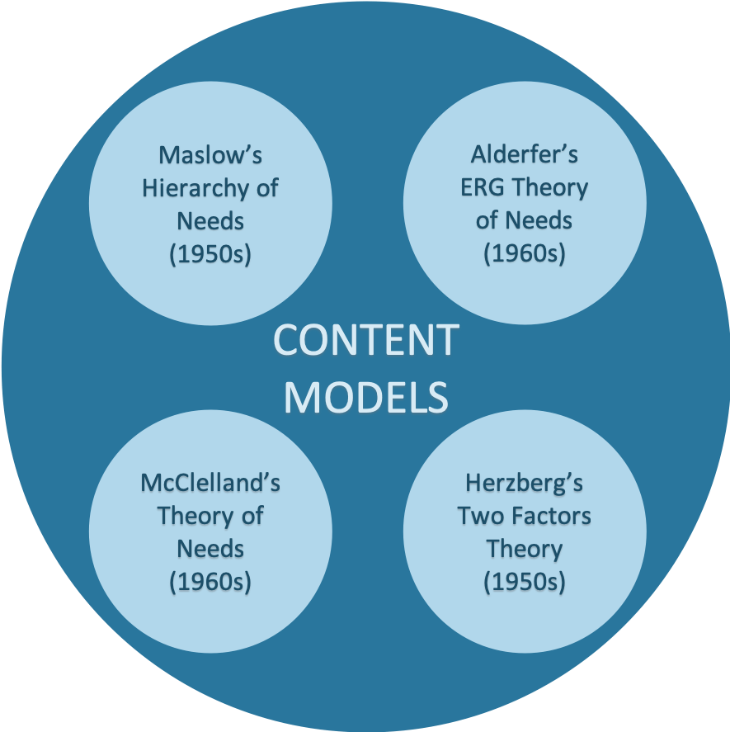

**Process Models of Motivation**

Process theories of motivation focus on the “*hows*” of motivation. Instead of focusing on what people need, these models focus on the psychological and behavioral processes that humans follow. By understanding these processes it’s possible to understand the actions, interactions and contexts that motivate individuals’ behaviors.

The process school of motivation is the newer of the two schools. These process models are influencing leadership and management theory more and more.

Some famous process theories of motivation include:

* [Skinner’s reinforcement theory](https://worldofwork.io/2019/07/reinforcement-theory/),
* [Vroom’s Expectancy Theory](https://worldofwork.io/2019/02/vrooms-expectancy-theory-of-motivation/),
* [Adam’s Equity Theory](https://worldofwork.io/2019/02/adams-equity-theory-of-motivation/), and
* [Locke’s Goal Setting Theory](https://worldofwork.io/2019/07/locke-lathams-goal-setting-theory/).

